INDIAN ASSOCIATION FOR WOMEN’S STUDIES
MEMBERSHIP FORM

Please fill in CAPITALS
Personal information
Name (in full):
Gender |  | Age

Educational qualifications

Permanent Address:

City |  | PIN |  | State

Phone |  | Mobile

E.mail:

Mailing Address:
(if different from above)

Interest in Women’s Studies (Please tick categories applicable)
Teaching/ |  | Activism |  | Writing

Research |  | Media & Communication |  | Administration of Programmes
Any other

Life Membership (Rs.1500/-)

Student (Rs.250/-) (valid for 3 years) (Attach proof of Student ID)(Age limit is below 35 years)

Institutional (Life) Rs.10000/-

Friends of Association $100 (in Rupees equivalent)

Details of Payment:
DD/ Cheque No. or UPI Reference |  | Date: |  | Rs.

Bank: |  | Branch:

Place: |  | Date: |  | Signature:

For Electronic Bank Transfer
NAME OF BENEFICIARY: INDIAN ASSOCIATION FOR WOMEN’S STUDIES
BANK NAME : INDIAN OVERSEAS BANK
BRANCH OF BANK: GOLE MARKET
ADDRESS OF THE BANK : 94, BANGLA SAHIB ROAD, NEW DELHI – 110 001
TYPE OF ACCOUNT : SAVINGS BANK ACCOUNT
ACCOUNT NUMBER: 084001000017542
IFS CODE : IOBA0000840
SWIFT CODE : IOBAINBBA997

BY CHEQUE/DD: NAME: INDIAN ASSOCIATION FOR WOMEN’S STUDIES

Note: Please mention the Transaction ID, Date and sender’s name and mark as ‘Membership fee’ in Debit/Credit column.

PAY BY UPI

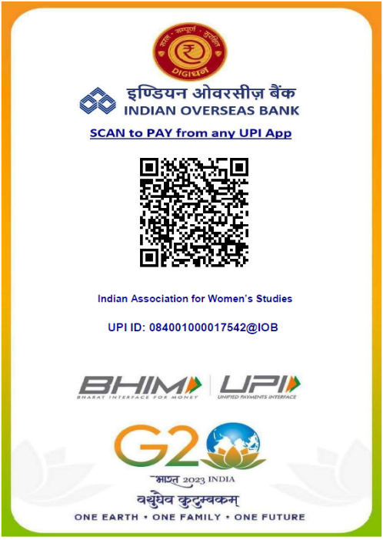

Postal Address:
Ms. Mini Sukumar
General Secretary
Indian Association for Women's Studies
C/o. Department of Women’s Studies
University of Calicut
Malappuram District
Kerala 673 635
E.mail: iaws.secretariat@gmail.com
Ph: +91-0494-2407366, 2407339

